采购订单预览界面点击新增可弹出“采购订单编辑窗口”，并能录入采购订单数据。当点击编辑按钮时，系统提示“‘）’号附近有语法错误，“采购订单编辑窗口”无法打开，附图如下。

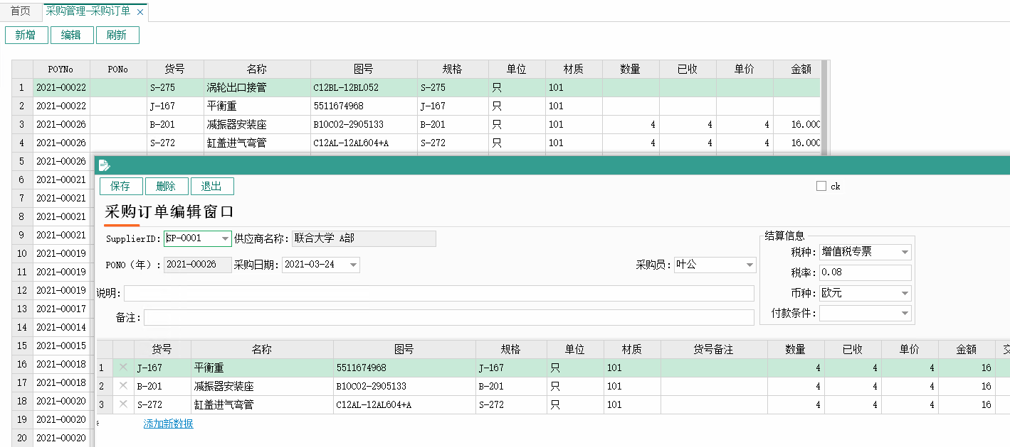

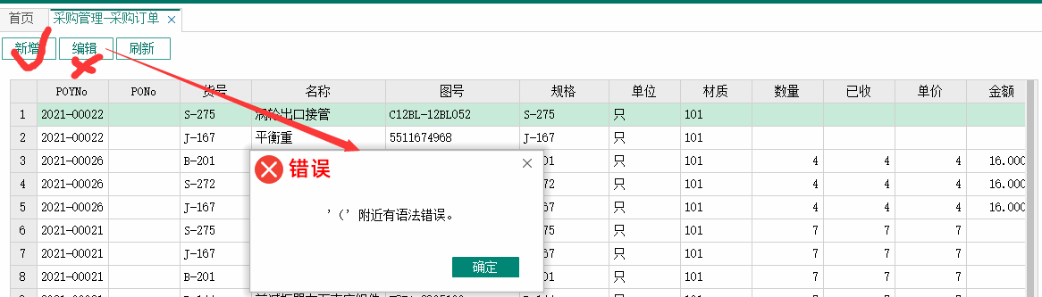

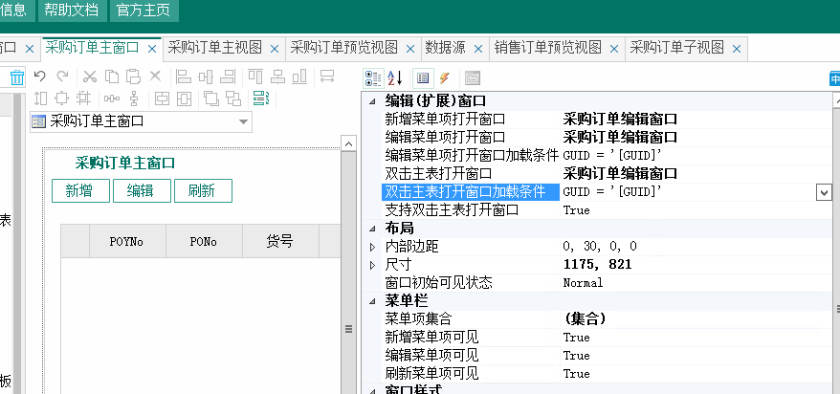

Select Po2.ID,Po2.Guid,Po2.PO1Guid,Po2.ItemGuid,Po2.创建人,Po2.创建日期,Po2.修改人,Po2.修改日期,T_yf_item.货号,T_yf_item.名称,T_yf_item.图号,T_yf_item.规格,T_yf_item.单位,T_yf_item.材质,T_yf_item.备注 As 货号备注,Po2.POQty As 数量,Po2.RecQty As 已收,Po2.Price As 单价,Po2.Amount As 金额,Po2.StartDate As 交付日期,Po2.FinishDate As 实际交付日期,Po2.Finish As 完成,Po2.PriceBase As 定价标准,Po2.Remarks2 As 备注 From Po2 Left Outer Join T_yf_item On Po2.ItemGuid = T_yf_item.Guid